**Task 1: Simple Programs to do for variables**

1. Declare four variables without assigning values and print them in console

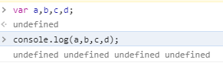

**2.** How to get value of the variable myvar as output

var myvar= 1;  
console.log("myvar");

**Ans:** var myvar=1;

console.log(myvar);

3.Declare variables to store your first name, last name, marital status, country and age in multiple lines

var fname =“Sathiyapriya”;

var lname=“Rajendran”;

var mstatus="single";

var country=“India”;

var age=“56”;

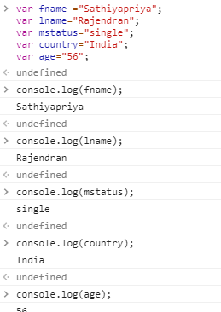

4. Declare variables to store your first name, last name, marital status, country and age in a single line

var details = [“Sathiyapriya”, “Rajendran”, “single”, “India”, “age”];

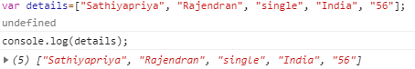

5. Declare variables and assign string, boolean, undefined and null data types

var strvar= “sathiya”;

var bvar= true;

var intvar;

var a=null;

7. Write 6 statement which provide truthy & falsey values.

* !(4 === 4) && "STRing" === "STRing" - false
* 11!= 12 - true
* 3 < -10 || "James" !== "james" - true

# Task 2: Simple Programs todo for Operators

# 1.Square of a number

# var N = userInput[0];

# var square = N * N;

# console.log(square);

# 2.Swapping 2 numbers

# let a = 1;

# let b = 2;

# let temp;

# temp = a;

# a = b;

# b = temp;

# console.log(a);

# console.log(b);

# 

# 3.Addition of 3 numbers

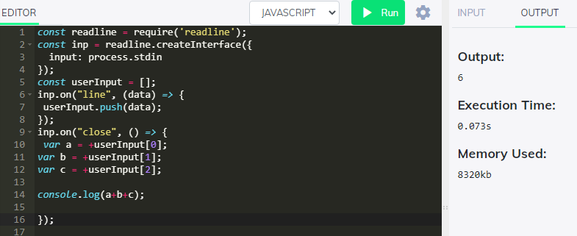

# 4.Celsius to Fahrenheit conversion

const readline = require('readline');

const inp = readline.createInterface({

  input: process.stdin

});

const userInput = [];

inp.on("line", (data) => {

 userInput.push(data);

});

inp.on("close", () => {

var a = +userInput[0];

console.log(Math.round((a*1.8+32)*100)/100)

});

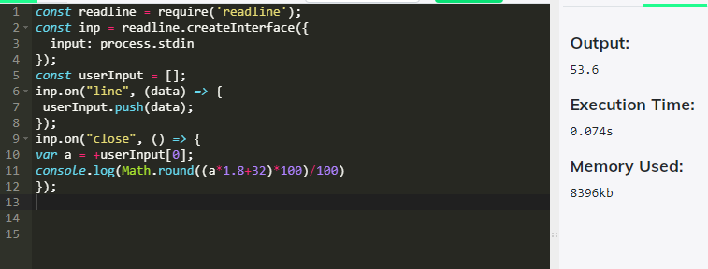

# 5.Meter to miles

# const readline = require('readline');

# const inp = readline.createInterface({

# input: process.stdin

# });

# const userInput = [];

# inp.on("line", (data) => {

# userInput.push(data);

# });

# inp.on("close", () => {

# var M = userInput[0];

# var m = M / 1609;

# console.log(m);

# });

# 

# 6.Pounds to kg

# const readline = require('readline');

# const inp = readline.createInterface({

# input: process.stdin

# });

# const userInput = [];

# inp.on("line", (data) => {

# userInput.push(data);

# });

# inp.on("close", () => {

# var p = userInput[0];

# var kg = p / 2.205;

# console.log(kg);

# });

# 

# 7.Calculate Batting Average

# const readline = require('readline');

# const inp = readline.createInterface({

# input: process.stdin

# });

# const userInput = [];

# inp.on("line", (data) => {

# userInput.push(data);

# });

# inp.on("close", () => {

# var runs = userInput[0];

# var timesOut = userInput[1];

# var BA =runs / timesOut;

# console.log(BA);

# });

# 

# 8.Calculate five test scores and print their average

# const readline = require('readline');

# const inp = readline.createInterface({

# input: process.stdin

# });

# const userInput = [];

# inp.on("line", (data) => {

# userInput.push(data);

# });

# inp.on("close", () => {

# var a = +userInput[0];

# var b = +userInput[1];

# var c = +userInput[2];

# var d = +userInput[3];

# var e = +userInput[4];

# var Average = (a + b + c + d + e)/5;

# console.log(Average);

# });

# 

# 9.Power of any number x ^ y.

# const readline = require('readline');

# const inp = readline.createInterface({

# input: process.stdin

# });

# const userInput = [];

# inp.on("line", (data) => {

# userInput.push(data);

# });

# inp.on("close", () => {

# var x = +userInput[0];

# var y = +userInput[1];

# var power = Math.pow(x,y);

# console.log(power);

# });

# 

# 10.Calculate Simple Interest

# const readline = require('readline');

# const inp = readline.createInterface({

# input: process.stdin

# });

# const userInput = [];

# inp.on("line", (data) => {

# userInput.push(data);

# });

# inp.on("close", () => {

# var P = +userInput[0];

# var r = +userInput[1];

# var t = +userInput[2];

# var SI = P * (1 + ((r/100) * t));

# console.log(SI);

# });

# 

11.Calculate area of an equilateral triangle

const readline = require('readline');

const inp = readline.createInterface({

  input: process.stdin

});

const userInput = [];

inp.on("line", (data) => {

 userInput.push(data);

});

inp.on("close", () => {

var a = +userInput[0];

var Area = (Math.pow(3,1/2)* a * a)/4

//var Area = (Math.sqrt(3)* a * a)/4

console.log(Math.round(Area*100)/100)

});

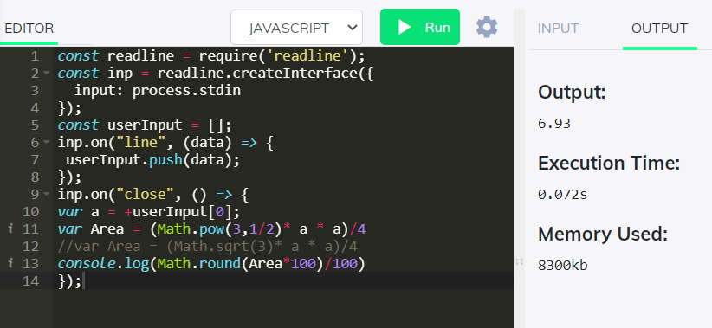

# 12.Area Of Isosceles Triangle

# const readline = require('readline');

# const inp = readline.createInterface({

# input: process.stdin

# });

# const userInput = [];

# inp.on("line", (data) => {

# userInput.push(data);

# });

# inp.on("close", () => {

# var b = userInput[0];

# var h = userInput[1];

# var Area = (b * h)/2;

# console.log(Area);

# });

# 

# 13.Volume Of Sphere

# const readline = require('readline');

# const inp = readline.createInterface({

# input: process.stdin

# });

# const userInput = [];

# inp.on("line", (data) => {

# userInput.push(data);

# });

# inp.on("close", () => {

# var r = userInput[0];

# var vol = 4/3 * (3.14 * r * r);

# console.log(vol.toFixed (02));

# });

# 

# 14.Volume Of Prism

# const readline = require('readline');

# const inp = readline.createInterface({

# input: process.stdin

# });

# const userInput = [];

# inp.on("line", (data) => {

# userInput.push(data);

# });

# inp.on("close", () => {

# var l = userInput[0];

# var b = userInput[1];

# var h = userInput[2];

# var vol = (l * b * h)/2;

# console.log(vol.toFixed (02));

# });

# 

# 15.Find area of a triangle.

# const readline = require('readline');

# const inp = readline.createInterface({

# input: process.stdin

# });

# const userInput = [];

# inp.on("line", (data) => {

# userInput.push(data);

# });

# inp.on("close", () => {

# var h = userInput[0];

# var b = userInput[1];

# var Area = 1/2 * (b * h);

# console.log(Area);

# });

# 

# 16.Give the Actual cost and Sold cost, Calculate Discount Of Product

# const readline = require('readline');

# const inp = readline.createInterface({

# input: process.stdin

# });

# const userInput = [];

# inp.on("line", (data) => {

# userInput.push(data);

# });

# inp.on("close", () => {

# var CP = userInput[0];

# var SP = userInput[1];

# var discount = CP - SP;

# console.log(discount);

# });

# 

# 17.Given their radius of a circle and find its diameter, circumference and area.

# const readline = require('readline');

# const inp = readline.createInterface({

# input: process.stdin

# });

# const userInput = [];

# inp.on("line", (data) => {

# userInput.push(data);

# });

# inp.on("close", () => {

# var r = userInput[0];

# var d = 2 * r;

# var c = 2 * 3.14 * r;

# console.log(d);

# console.log(c);

# });

# 

# 18.Given two numbers and perform all arithmetic operations.

# const readline = require('readline');

# const inp = readline.createInterface({

# input: process.stdin

# });

# const userInput = [];

# inp.on("line", (data) => {

# userInput.push(data);

# });

# inp.on("close", () => {

# var a = +userInput[0];

# var b = +userInput[1];

# console.log(a + b);

# console.log(a - b);

# console.log(a * b);

# console.log(a / b);

# });

# 

# 19.Display the asterisk pattern as shown below(No loop needed):

# console.log("*****");

# console.log("*****");

# console.log("*****");

# console.log("*****");

# console.log("*****");

# 

# 20.Program To Calculate CGPA

# const readline = require('readline');

# const inp = readline.createInterface({

# input: process.stdin

# });

# const userInput = [];

# inp.on("line", (data) => {

# userInput.push(data);

# });

# inp.on("close", () => {

# var a = +userInput[0];

# var b = +userInput[1];

# var avg = +userInput[2];

# var GPA = a + b;

# var CGPA = (a + b)/avg;

# console.log(CGPA);

# });

# 

# Task 3: Simple Programs todo for Condition , Looping and Arrays

1. 1. Write a loop that makes seven calls to console.log to output the following triangle:

#  
##  
###  
####  
#####  
######  
#######

# 

2. Iterate through the string array and print it contents

var strArray= ["<option>Jazz</option>",  
 ,<option>Blues</option>",  
 ,<option>New Age</option>",  
 ,<option>Classical</option>",  
 ,<option>Opera</option>"]

# 

Create an array called foods holds the names of your top 20 favorite foods, starting with the best food.

let foods = [“pizza”, “burger”, “momos”, “Dosa”, “chapathi”, “Idly”, “chicken”, “biriyani” , “tandoori”, “prawn”, “crab”, “squid”, “egg”, “noodles”, “brownie”, “fish finger”, “paratta”, “panneer”, “cake”, “icecream”];

# — — — — — — — — — — — — — — — -

Foods variable holds the names of your top 20 favorite foods, starting with the best food. How can you find your fifth favorite food?

let foods=[]

Find the length of your foods array



                